|  |  |  |  |  |  |
| --- | --- | --- | --- | --- | --- |
| Date | 23-Sep-22 | | | Tester Name | Andrew McLaughlin |
| Environment | Penfax - Test | | | Login used |  |
| Operating System | Windows | Version: | Update: | | |
| Software Used | Edge | Version: | Update: | | |
| Select Software | Version: | Update: | | |
| Release version |  | | | | |
| Title | M46.06 Bridge ended during year to which indexing applied | | | | |
| Test Type | Regression | | | | |
| Test Scenario | M46.06 Bridge ended during year to which indexing applied | | | | |
|  |  | | | | |
| Expected Results |  | | | | |
| Pass/Fail | Pass | | | JIRA# | N/A |

Describe your steps with screenshots:

Run pre-indexing query for PSSP – **Query Available on Page 3 here**: H:\Quality Assurance\Prod Apps\PenfaxV5\MEPP\Procedures\How to Run Indexing in Penfax 5.docx

Apply indexation rate for PSSP with benefits commencing 01-JAN-1900, effective date the day you want them to start, for **every Recipient Type and Income Amount Type**. 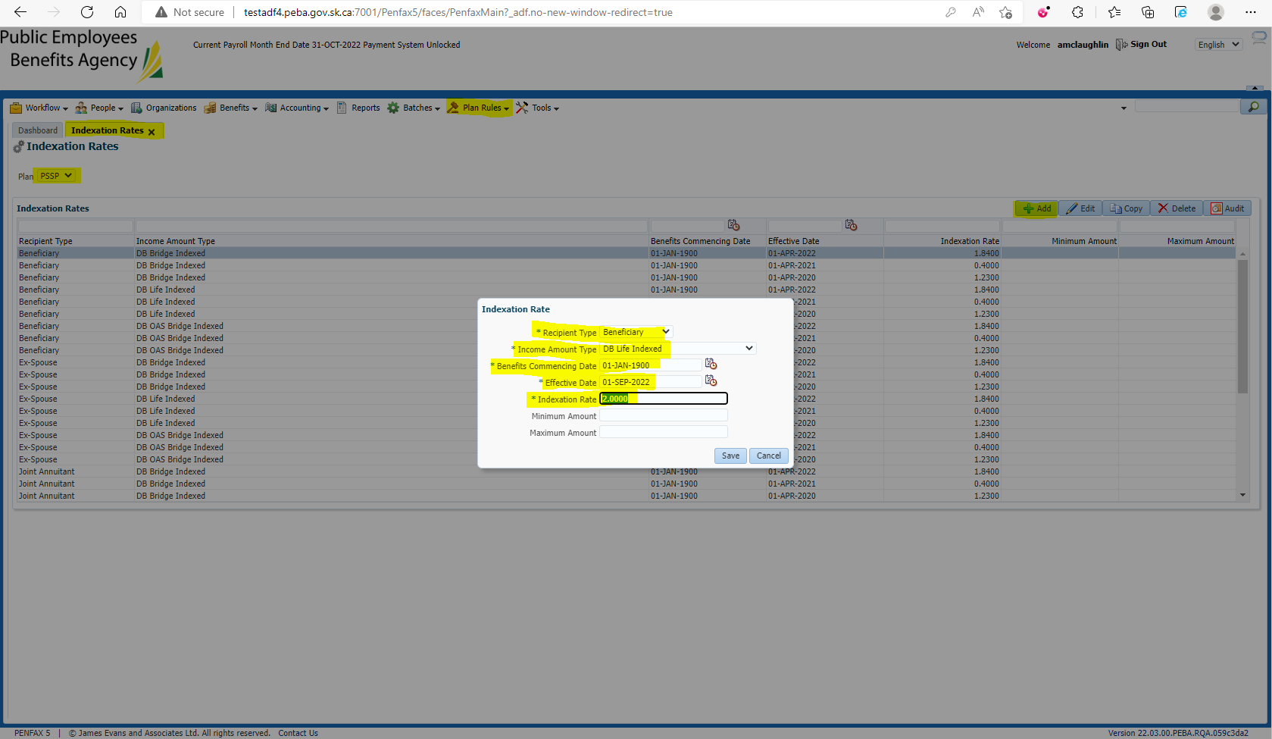

Run post indexing query for PSSP **Query Available on Page 5 here**: H:\Quality Assurance\Prod Apps\PenfaxV5\MEPP\Procedures\How to Run Indexing in Penfax 5.docx

Run the Indexation Batch for the Plan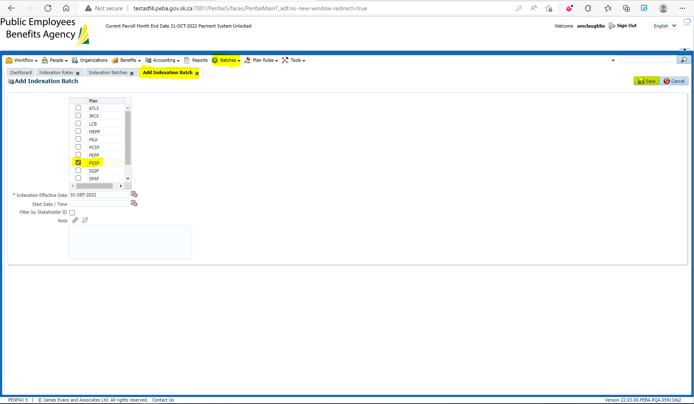

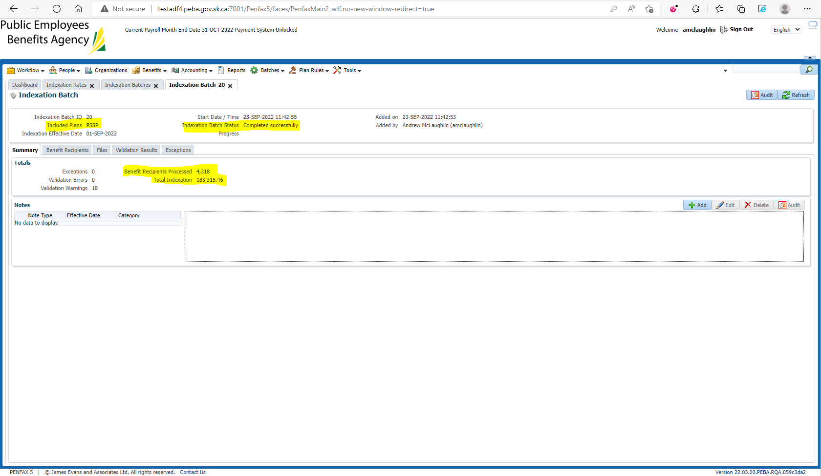

Compare the amounts b/w pre and post indexing query results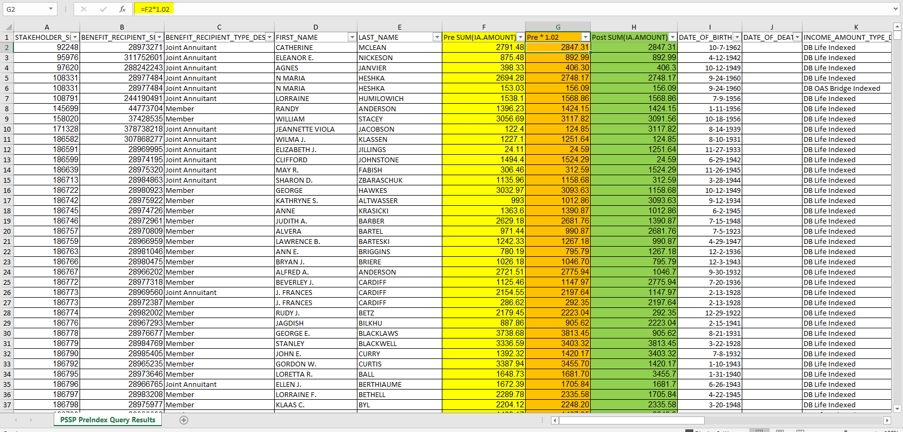

Check a member with a bridge that ended during the year to which indexing applied

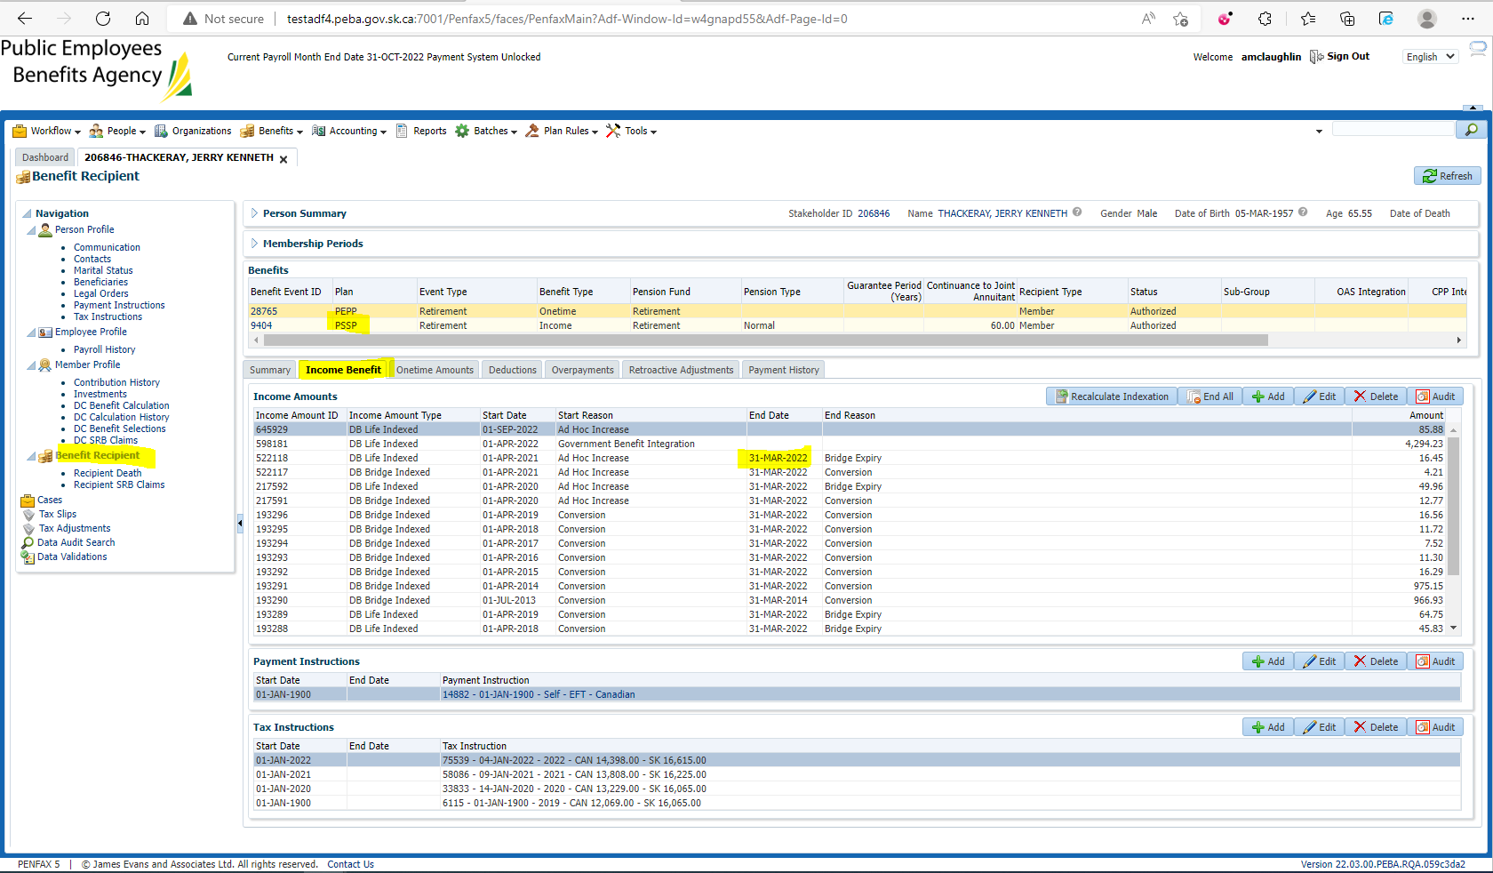

Check Previous Gross Amount 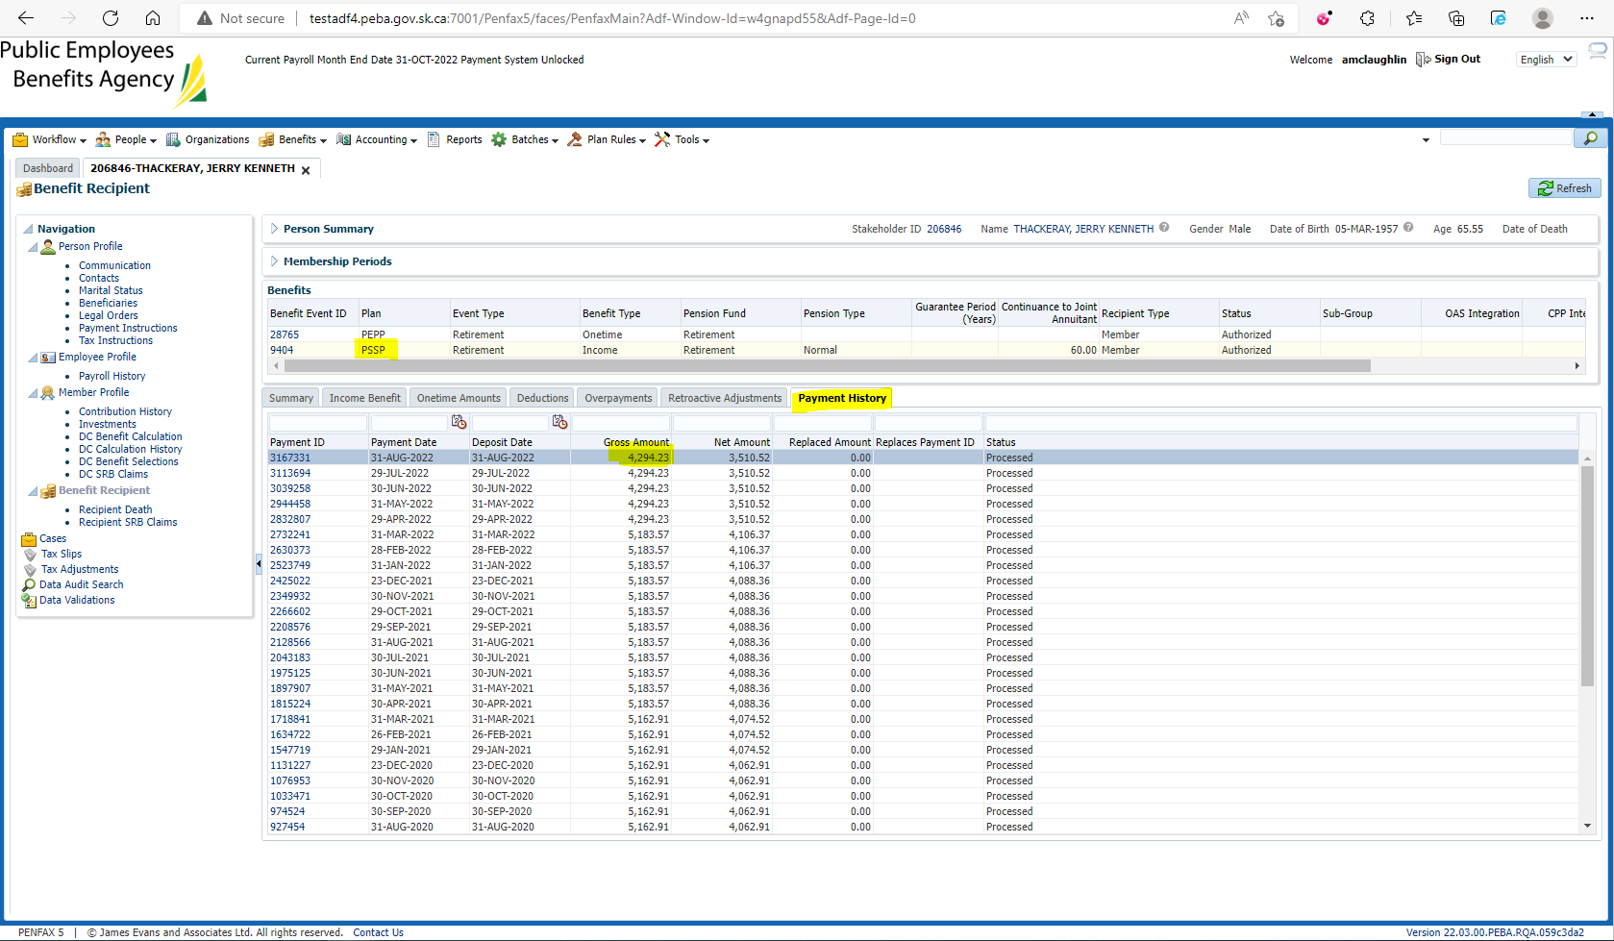

Compared to New Current Amount 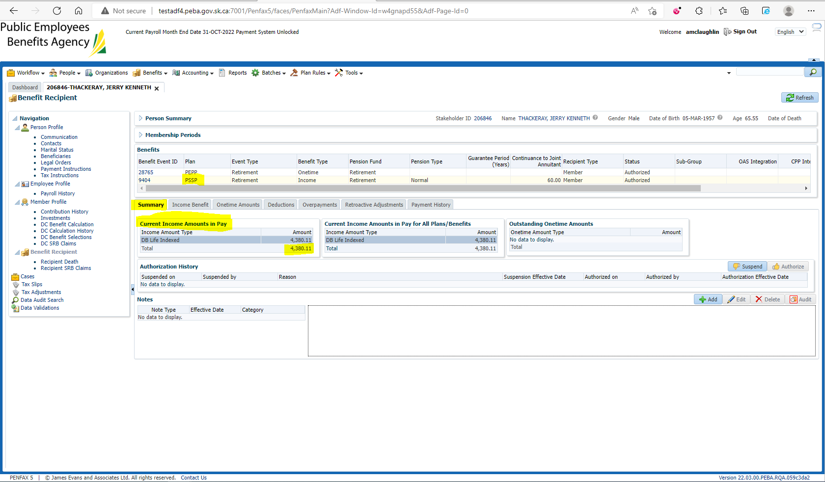

Ensure individual lines in Income have received their increases and are being displayed correctly 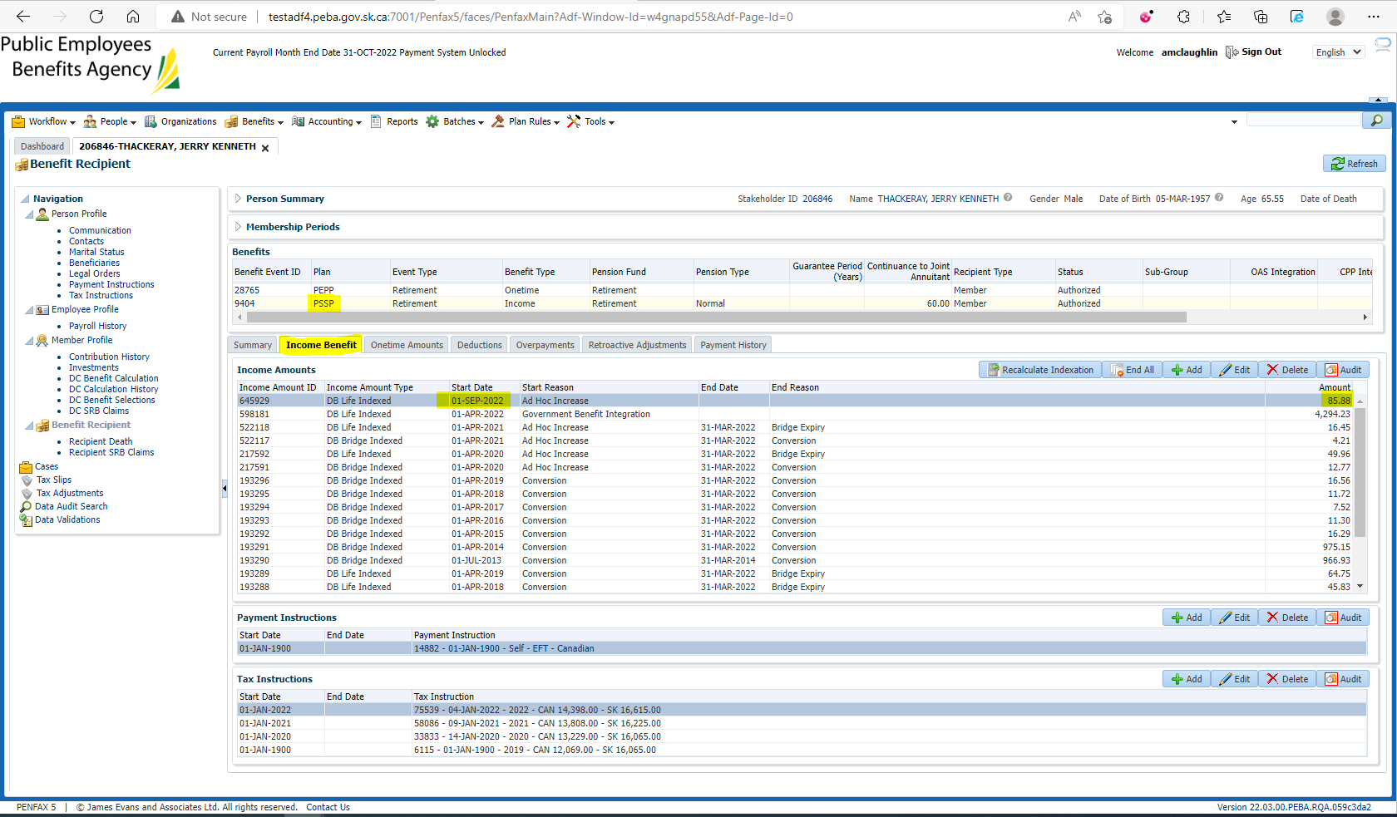

$4,294.23 * 2% = $85.88